A Framework for the Development of Java Applets and Servlets
Amndeep Singh Mann
TJHSST Computer Systems Research – Gabor – 2013

Abstract
Web development is an increasingly important part of the programming community, with ever more financial incentive for people to work in this portion of the community. This implies that people need to learn how to develop for the web, which is substantially different from desktop application development, where most novice programmers learn how to program. Consequentially, the development of web applications, such as Java applets and servlets, can be difficult for novices to web development. If there were an extensible framework and basic guide in creating applets and servlets, the web technologies most closely associated with Java, the world’s second most popular language [1], that were free and open-source, then it would lower the barrier in using these technologies. The creation of such a framework was the focus of my project.

Introduction
It can be difficult to create a web application that is able to do computationally intensive tasks, such as running a simulation, without programming both server and client-side. Java, a language with which I was already familiar, enables one to do so with more or less difficulty. With this Java framework, I intended to reduce the average difficulty of such development for novices in this area.
Initially, my project was going to be concerning an entirely different topic. The original intent of this project was to create a simulation of a GPS transceiver. Such a device would be able to help with driving through local traffic as opposed to just the larger traffic situations that current generation GPS receivers accommodate for. However, within the acceptance of my proposal was a clause that stated that my application needed to be web-based. I originally was intending on having the simulation be a desktop application, but based on this requirement, it now had to be a web application. I decided to get a web-backend set up first in order that I wouldn’t need to work with it while I wrote the actual simulation. I also decided that if I was going to be making a web-application, then would follow common practices with a GUI running from the applet, and the actual simulation controlled by the servlet.
Unfortunately, the process in setting up such a back-end for my simulation took a considerable portion of the school year. I eventually realized that I would not have enough time to create the simulation that I had intended to make, as I was spending so much time in getting the applet and servlet base set up. Therefore, I made the applet/servlet framework my project, and set it up so that it would be useable by anyone who chose to do so. My rationale was that if I were having such difficulties in setting it up, then many others would probably be having this issue as well.
The framework that resulted is intended for use by novices, though it is not intended to be just copy-pasted into what they are making in order to make their code work. The purpose was to make it extensible so that they could use my framework as a basis for their own creations. More experienced developers would be able to craft an applet/servlet application that would be more concise, powerful, and uniquely tailored for their needs than any extension of my framework. Such developers would have no need to use my framework; nevertheless, the manner in which the framework was designed allows for the novice to extend it in order to create their own work in as independent a manner as they could possibly desire.
Possible applications include all manners that applets and servlets are used for. When these technologies initially came out, they were used to make web pages interactive through web applications, such as games, simulations, and business applications [2][3]. Unfortunately, those technologies were not the most mature, resulting in the justified creation and use of other programming technologies, such as PHP [4]. Today, applets and servlets are reserved for more computationally intensive applications, or as alternatives for the more dominant web technologies, such as Flash and Javascript [2]. These more computationally intensive applications generally include such things as visualizations of 3D models and multi-agent simulations. Included with the framework is an “application,” or example of its use, which runs and displays a Boids simulation.

Development
Java’s web technologies, namely applets and servlets have been with the language from the very beginning. Applets were in the original release of Java in 1995 [5][6], and servlets followed shortly thereafter in 1997 [7].
Fig. 1 Structure of a typical applet/servlet application. [8]
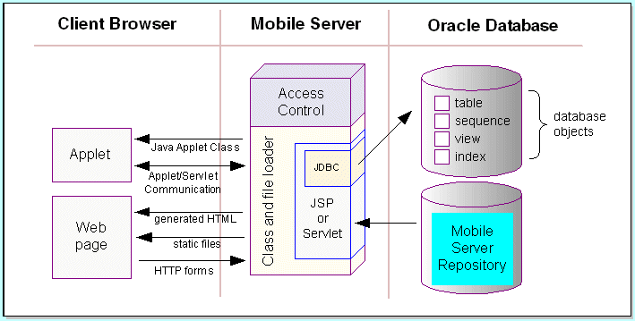
Java applets are small applications designed to run within other applications, namely the user’s web browser. Though they can mimic desktop applications in usage, they generally do not considering the security and resource restrictions placed upon them, which generally leave cause them to be relatively simple. They were originally used because of their small size and cross-platform nature; unfortunately, they are increasingly not used, even to the extent that major browsers are no longer supporting HTML tags for them or any Java support at all, because of numerous security exploits and the effectiveness of other tools [2]. Consequentially, applets are primarily left to those who desire, or even need, to use the full expressiveness of a mature programming language, which generally imply the need for applications that are more complex or computationally intense than the other tools, such as JavaScript, can handle.
Java servlet applications are similar to applets in that they do not run on the desktop. These applications instead run on a Web server. The primary difference between applets and servlets in user interaction is that the user directly interacts with the applet, as with a normal desktop application, ex. mouse clicks and/or keyboard taps, but indirectly with the servlet, which generally receives, processes, and returns HTML requests [9]. The primary difference in the functionality of the two is that, since the developer/maintainer is intimately familiar with the servlet, more permissions can be granted to it, allowing it to be used with powers and capabilities closer to an actual desktop application [10]. The combination of applets and servlets allow those familiar with the Java programming language to make Web applications, where the applet handles the GUI and the servlet does the majority of the actual computation.
As applets run on top of a browser, servlets run on top of servers. Servers can be any computer that has a connection to the Internet and has the appropriate software on it; however, they have traditionally been dedicated devices. There are also many types of servers, the one most relevant to this project being a Web server, which hosts websites [9]. One of the most common types of server software is the Apache Software Foundation’s Apache HTTP Server. Due to it being free and open source, it is often used by webmasters, along with a Linux distribution, as a Web hosting configuration. While the Apache HTTP Server is capable of both static websites, which just display an unchanging website, and dynamic websites, which allow interactivity to occur through the use of server-side scripting, those scripting languages have mainly been limited to PHP, Python, and Perl - support for other languages, such as Java, is limited [11]. Therefore, to test the framework, I used the Apache Tomcat server software, also provided by the Apache Software Foundation, which was created for the purpose of using Java as the back-end language.
In the beginning of my research process, I spent a considerable amount of time setting everything up so that it works in the first place, which was a difficult task. I was a novice, so I had no idea how to accomplish even the simplest of goals. Consequentially, using the meager knowledge I had acquired, I tried to do something complex. Namely, run a Java servlet on an Apache HTTP server which would communicate with the client through Python. This failed miserably, even after many days dedicated to trying to make it work, and the help of Andrew Hamilton, TJHSST’s knowledgeable Sys. Admin. After other attempts to make Java work on the Apache HTTP server, I finally learned about Tomcat, which finally worked – after many more hours spent on setting it up. The signal-to-noise ratio is extremely low when one is trying to find information on how to set up a server, even a popular one such as Tomcat. This is due to conflicting instructions between versions of the software, different means through which the software can be installed, and the confused and often inaccurate advice given by people who are themselves novices as they document how they set up the software themselves in their blogs and websites. A website that I highly recommend contains the teaching notes of Chua Hock-Chuan, of Nanyang Technological University, which cover widely different fields in programming, with a sizable section devoted to Java-based server-side programming. In the first section listed there, he describes the exact process needed to install Tomcat on various operating systems [12]. After finally having it installed, and correctly modifying all of the configuration files, I then had to set up an applet and servlet.
Once again, because I was a novice, I did not know how to write applets and servlets. So in my research process, I also found a great deal of noise in the process of creating these applications. I finally found an example created by Frank Buß that detailed how to create an applet, a servlet, and have communication between the two. My work was based off of modifying and extending his simple “Hello, World” style example [13].
The framework consists of five main parts: a series of shared, static means of communication, which can be extended in a manner; a logger; an extensible applet; an extensible servlet; and a detailed example.
The manner in which the applet and servlet communicate is through an enum of commands from the applet to the servlet and an enum of messages from the servlet to the applet. The commands tell the servlet about the specific request that the applet has, such as to log some information. The messages tell the applet important information, such as whether the receipt of the command failed in some manner. Though it can be called and used by the end-developer, this basic system is static and final. The reason for this is that if it were possible to add custom fields to an enum, it would break the “promise” of the enum of providing a static and constant list of fields [14]. Consequentially, the example provides a way to get around this issue, namely by setting up another message system in parallel for custom commands and messages. I went through several other possible mechanisms, such as maintaining a list of strings that would be the message types in both the applet and the servlet classes. I eventually realized the fallacies in that design decision and changed it to remove the code smell.
The logger is a very important part of the framework. It was extremely useful in recording the current state of the application, similar to how a programmer could check output on the terminal to ensure the expected outcomes were occurring. Due to security issues, the logger is based in the servlet, as it is not always possible to get permissions to create files on a client's computer in order to record all of that logging information. And even if permission would be granted, it would still be difficult to have Java ask for permission in the first place since it would require special, signed packaging of the entire program, which I would not be able to give since it depends on the final product of the end-developer [15]. Moreover, setting up such signed packaging would probably be beyond the skill, or at least scope of learning, of the novice programmer, which this framework is aimed towards. Therefore, the manner in which the applet logs messages is to accesses the logger in the servlet by sending a command to the servlet to log an attached message. Initially, I was not intending on adding a logger, but after spending many days trying to figure out an error in which the servlet was sending out one object, but the applet was expecting another, I implemented a logging system where, after looking at the logs, I saw the type mismatch. Such a simple error would usually be immediately discovered by the compiler due to Java’s strong, static typing, but when objects are transmitted, Java can’t tell what object it actually is before run-time [16].
The applet is sparse in content. While normally applets have code to display a GUI, the framework applet does not contain any such code because that is always implementation dependent. Instead it contains the necessary methods through which the end-developer can send and receive messages and objects with the servlet. It also contains a way to temporarily store errors so that they can be passed along to the servlet and, if desired, displayed on the screen, in case access to a servlet is not desired or not possible. I often had problems with getting the most recent version of the applet to display until I learned that often applets were cached by browsers, and so it was necessary to put the appropriate headers in the website’s HTML and refresh the webpage every so often [17].
The servlet is also relatively sparse in content. It sets up the logger and writes to it when told to do so. It also manages the different connections it receives from any applet that tries to connect to it. Part of this management entails sending and receiving messages with each applet. It also contains the necessary methods, which can be overridden by the end-developer, that specify what sort of input the servlet is looking for and what it will do when it receives it. This is where the parallel communication system comes into play. The other system overrides this method, checks if any custom messages are there, and appropriately deals with them if that is the case. Otherwise, it sends it to the framework’s communication system.
This framework itself is intended to be as DRY and extensible as possible, in order to facilitate the development of Java applets and servlets. The lack of many features was intentional so that the learning curve attached with using the framework would be reduced, and so that the end-developer would have as much freedom as he or she desired in creating an implementation of their ideas.
The examples and documentation will certainly be the item of most interest and use to an end-developer. He or she will be guided through example on how to create an applet and servlet, using my framework as a basis if they so desire. This process, to the unexperienced, is long and difficult, filled with a vast number of unknown, incomprehensible bugs and errors. Through the use of these examples and documentation, the end-developer will be able to quickly produce an applet and servlet. The detailed example provided is a modified Boids simulation.
Boids is a basic flocking model that consists of three steering behaviors – separation, alignment, and cohesion – that describe how an individual boid, the agent, maneuvers based on the positions and velocities of its nearby flock mates. The separation behavior causes each boid to steer so as to avoid crowding local flock mates. The alignment behavior causes each boid to steer towards the average heading of local flock mates. The cohesion behavior causes each boid to steer towards the average position of local flock mates. Through these simple behaviors, emergent behavior seems to occur, similar to how creatures, such as birds, flock in real life [18]. The modification that I applied to the traditional simulation is to place all of the boids along a grid, so that they can only move along it and can only change direction at the intersections. This modification, while maintaining the important of matching heading and speed, does not work so well for the cohesion behavior, so that behavior was not implemented.
Fig. 2 A screenshot of the applet.
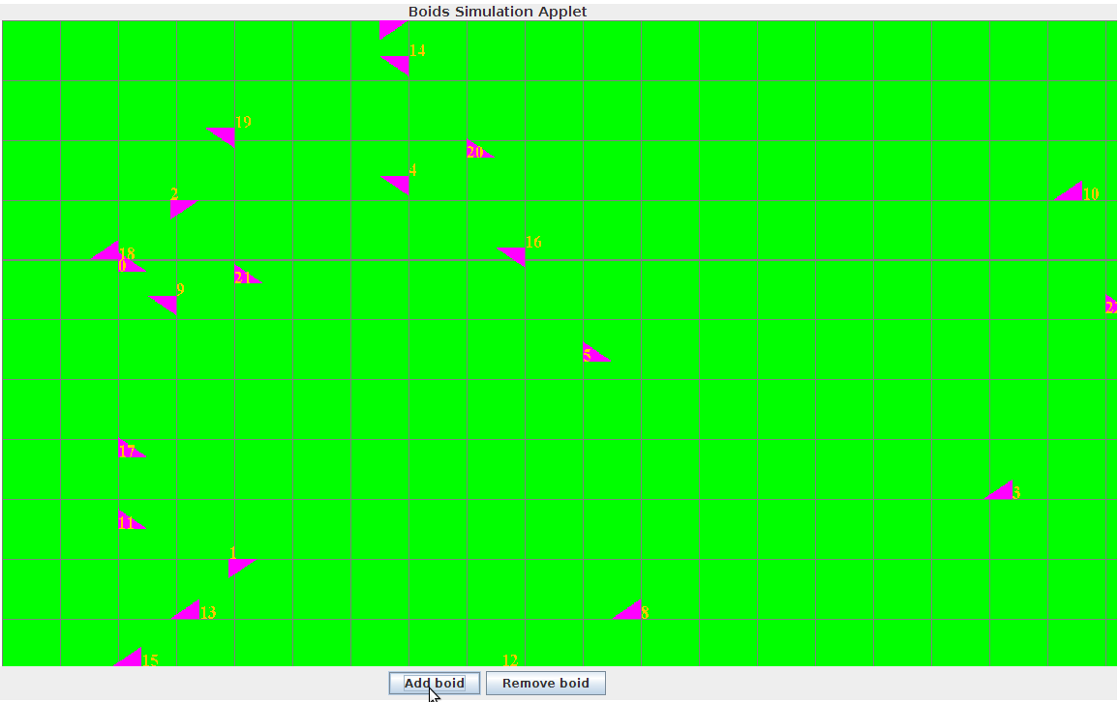
This example is subdivided into three sections reminiscent of the rest of the framework, namely it consists of the applet, the servlet, and shared code. The applet code consists of an extension of the framework’s applet, along with related GUI code. The servlet code consists of an extension of the framework’s servlet, along with code that creates and runs the simulation. The shared code consists of the new messages and other communication that the Boids simulation required, along with the necessary abstractions, such as a boid class.
The new applet contains all of the code to display a GUI, namely ways to interact with the display and the simulation, and display the simulation running. The actual simulation display is in another class so as to clearly divide the applet and the actual display. The new servlet contains the code required to handle each simulation for each individual applet, handling communication appropriately, and actually running the simulation appropriately so as to not cause any memory leaks. The memory leaks are an important issue as the applet and servlet are expected to work for a long time, but if there were a memory leak, it would cause the application to eventually crash due to running out of space [19]. The manner in which I handled the simulations was through multi-threading so that each simulation had its own thread, which caused many problems in making sure that everything synced up and shut down properly. That section also contains the actual simulation of the Boids flocking behaviors, managing all of the boids, changing their characteristics, and so on. The shared code contains a Boid class, which contains all of the necessary fields and methods to work in the simulation and display itself graphically. The shared code also contains the necessary new communication commands.

Conclusion
This project was an enlightening experience in learning how to do web development. In particular it highlighted the differences in programming style and in programming environment from desktop development. I hope that others could use my work as a stepping stone to creating their own work. To help with this, my framework is going to be available for all on Github at https://github.com/Amndeep7/Senior-Research-Project/, a project hosting site [20] that uses the popular distributed version control and source code management software Git [21]. It will also have a very lax license attached so all possible end-developers are sure about their rights in using the code.

References
- TIOBE Software, “TIOBE Programming Community Index,” http://www.tiobe.com/index.php/content/paperinfo/tpci/index.html, May 2013.

- TechTerms.com, “Applet,” http://www.techterms.com/definition/applet, January 20, 2012.

- TechTerms.com, “Server,” http://www.techterms.com/definition/server, November 29, 2011.

- The PHP Group, “History of PHP,” http://php.net/manual/en/history.php.php, June 7, 2013.

- Oracle, “Applet,” http://docs.oracle.com/javase/7/docs/api/java/applet/Applet.html.

- Oracle, “The History of Java Technology,” http://www.oracle.com/technetwork/java/javase/overview/javahistory-index-198355.html.

- Free Java Guide & Tutorials, “Java Servlet,” http://www.freejavaguide.com/java_servlet.html.

- Oracle, “Development Arc,” http://docs.oracle.com/html/A97671_01/img/dev_arc.gif.

- TechTerms.com, “Servlet,” http://www.techterms.com/definition/servlet, October 20, 2012.

- Sun Microsystems, “Users, Groups, and Roles,” http://www.inf.fu-berlin.de/lehre/WS02/P-WebServices/Docs/JWSDP/tutorial/doc/WebAppSecurity3.html.

- TechTerms.com, “Web Server,” http://www.techterms.com/definition/web_server, February 19, 2011.
- Chua Hock-Chuan, “Programming Notes,” http://www3.ntu.edu.sg/home/ehchua/programming/index.html, June 2013.

- Frank Buß, “Applet <-> Servlet communication,” http://www.frank-buss.de/echoservlet/index.html, September 2012.

- Jon Skeet, “Selected Answer to ‘Java extend enum,’” http://stackoverflow.com/questions/1414755/java-extend-enum, September 12, 2009.

- Oracle, “Signing and Verifying JAR Files,” http://docs.oracle.com/javase/tutorial/deployment/jar/signindex.html.

- Oracle, “Chapter 4. Types, Values, and Variables,” http://docs.oracle.com/javase/specs/jls/se7/html/jls-4.html.

- Oracle, “Applet Caching,” http://docs.oracle.com/javase/7/docs/technotes/guides/plugin/developer_guide/applet_caching.html.

- Craig Reynolds, “Boids,” http://www.red3d.com/cwr/boids/, September 6, 2001.

- Nikita Salnikov-Tarnovski, “What is a memory leak,” http://plumbr.eu/blog/what-is-a-memory-leak, February 15, 2012.

- Github, “About,” https://github.com/about.

- Git, “Git,” http://git-scm.com/.

